**MCM DAV COLLEGE FOR WOMEN**

**PROJECT**

**WEBSITE OF A HOTEL**

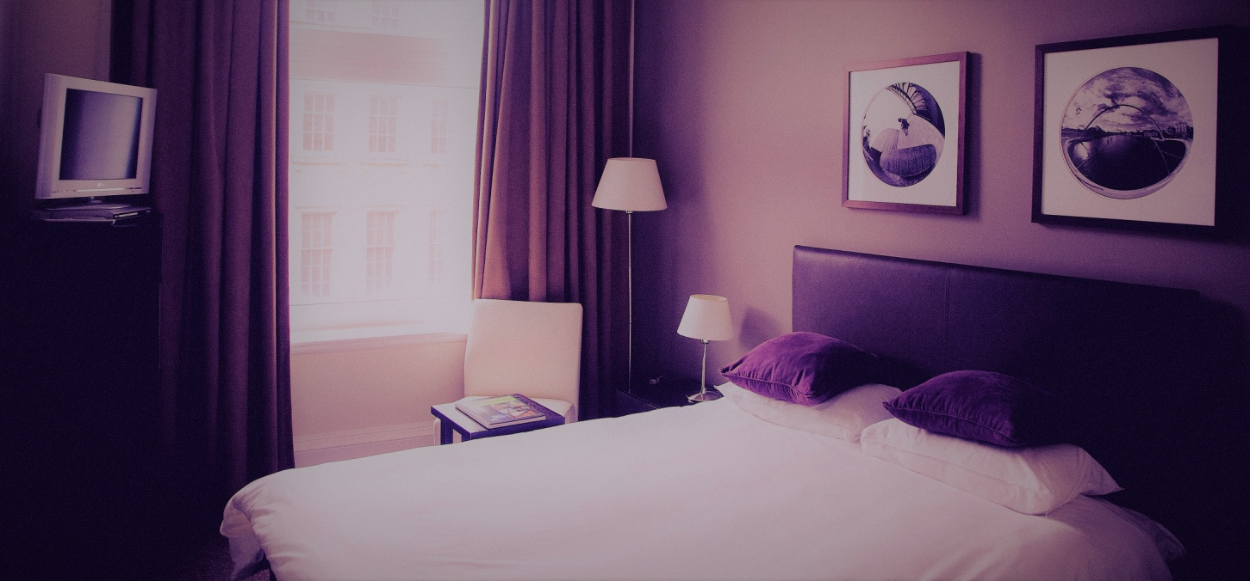

FOR THE PARTIAL FULLFILLMENT OF

DEGEREE OF BACHELOR OF

COMPUTER SCIENCE AND APPLICATIONS

(SESSION 2016-2017)

6Th semester

**Submitted to-**  **Submitted by-**

Dr.Indu Arora Urvashi Singh (6255)-14046451

Parusha Thakur(6226)-14046426

Simran Jaglan(6263)-14046438

**Acknowledgement**

We take this opportunity to express our profound gratitude to our teacher Dr.Indu Arora for her exemplary guidance, monitoring and constant encouragement throughout the course and during this project.

This project helped us in doing a lot of Research and we came to know about so many new things about javascript, HTML,CSS which will surely help us in our future studies.

Secondly we would also like to thank our friends who helped us in finalizing this project within the limited time frame and we are grateful for the cooperation during a period of our project.

Lastly we thank our parents for their constant encouragement without which the assignment would not be possible.

**INTRODUCTION**

**ABOUT THE PROJECT-**

TO SET UP A WEBSITE FOR THE HOTEL AND SERVICES PROVIDED BY THEM:

* SUITES AVAILABLE
* CONTACTS
* BOOKING OF THE HOTEL
* THE FEEDBACK-FORM

**OBJECTIVES:**

The main objective of the project is to help the user to find the hotel price according to their requirements and to know about the hotel site and what we are about to offer.

This project will help the user to book the hotel room with the specified dates of the user needs from which date to when they are in need to have the booking of the room

This will also help the user to select the particular place where they want to book their hotel right from their door helping them to have a convenient interaction with the hotel directly

By the contacts provided they can talk directly to the hotel premises regarding any queries they want to know for their satisfaction.

The site also provides them with the types of room available in the hotel with the prices with the minimum days of stay.

Not only helping the guest but also to the host by the form which they fill and help the host to know the feedback from the guest for the better interaction with our guest in the future minimizing the cumbersome task for the hotel people and making their work easy to recognize the particular guest by having their picture in the account.

Its also with the guest choice whether they want food to be included or not.

Through this website an individual can book his hotel very easily as this website is a very user friendly site and he can easily understand the contents and the services provided by the hotel.

* **HARDWARE USED-**

Laptop with the Intel core i3 processor

* **SOFTWARE USED-**

1. Window 7 ultimate
2. Notepad version 6.1(Build 7600)
3. Google Chrome for the working of JavaScript
4. Google Chrome for the pictures

* **LEARNING OUTCOMES-**

1. **How to use JavaScript-**

Firstly through this project we are able to make use of javascript. We are more familiar with the contents and the basics of using javascript and HTML. This project helped us to make our basics more strong on javascript.

1. **Methods to create a website-**

We learned different ways of creating a website and how different syntax and members of the java family ,HTML can help to create an eye catching website.

1. **To have a team work-**

While working on this project we were able to learn how to work in a team. We learnt that for the accomplishment of the project at right time team work and coordination between the members is an essential element.

1. **More knowledge regarding a particular subject-**

We after the completion of the project have more knowledge about the particular subject and hence this will surley in our future studies.

**SCREEN LAYOUTS-**

1. **HOME PAGE-**

The very first page of our website-THE HOMEPAGE

Defines the user about the hotel introduction and the measures they want to take regarding a particular hotel and the subpages on which they like to go.

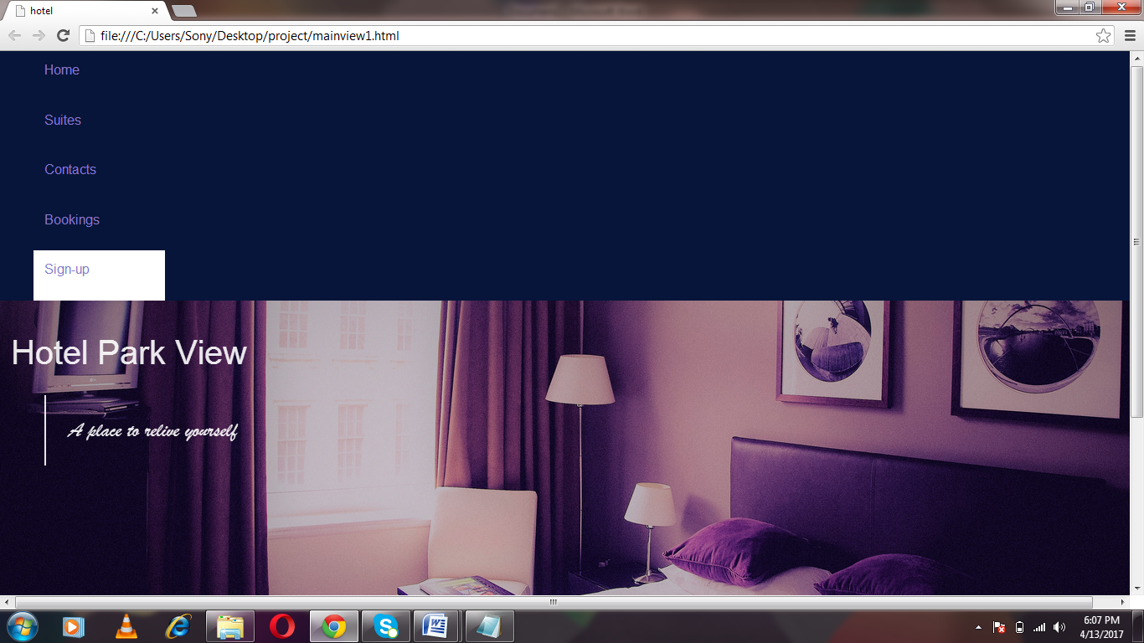

**Figure-1(a)**

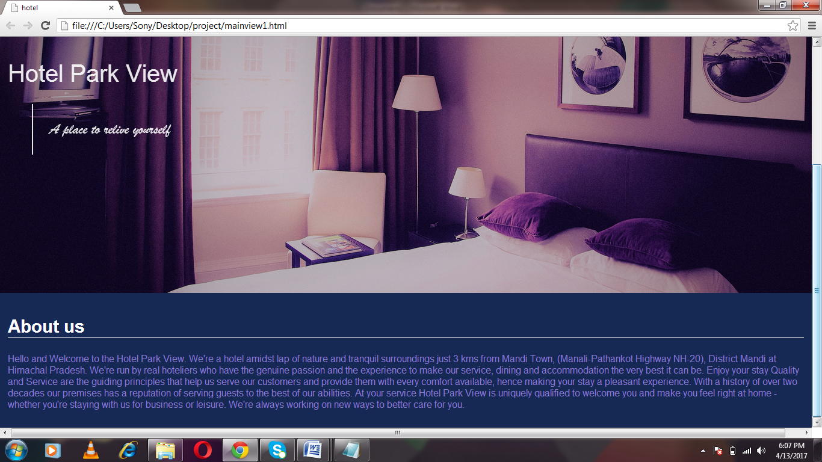

**Figure- 1(b)**

**CODE 1-**

|  |  |
| --- | --- |
|  |  |
|  |  |
|  | <!DOCTYPE html> |
|  | <html> |
|  | <head> |
|  | <meta charset="utf-8"> |
|  | <title>hotel</title> |
|  |  |
|  | <style> |
|  | body , html{ |
|  | padding: 0px; |
|  | margin: 0; |
|  | font-family: helvetica; |
|  | } |
|  | ul#nav{ |
|  | display: flex; |
|  | justify-content: flex-end; |
|  | background-color: #061539; |
|  |  |
|  | margin: 0; |
|  | } |
|  | li{ |
|  | height:5vh; |
|  | width:10%; |
|  | list-style-type: none; |
|  | background-color: #061539; |
|  | padding: 1%; |
|  |  |
|  | } |
|  |  |
|  | a{ |
|  | color:#887acf; |
|  | text-decoration: none; |
|  | } |
|  | li:hover{ |
|  | background-color:white; |
|  | color:#2331af; |
|  | } |
|  |  |
|  | div#store{ |
|  | display:flex; |
|  | flex-wrap: wrap; |
|  | width:100%; |
|  | background-color:#162955; |
|  | } |
|  |  |
|  | div#main_image{ |
|  | width:100%; |
|  | height: 60vh; |
|  | padding: 1%; |
|  | order:1; |
|  | } |
|  | div#content{ |
|  |  |
|  |  |
|  | color:#887acf; |
|  | order:2; |
|  | /*height:35vh;*/ |
|  | /*width:70%;*/ |
|  | padding: 1%; |
|  |  |
|  | } |
|  | div#content h2{ |
|  | color:white; |
|  | border-bottom: 1px solid white; |
|  | font-size:30px; |
|  |  |
|  |  |
|  | } |
|  | div#main_image{ |
|  | background:url("blueroom1.jpg"); |
|  | background-size: cover; |
|  | background-repeat: no-repeat; |
|  | background-position: center; |
|  | } |
|  | li#sign{ |
|  | background-color: white; |
|  | } |
|  | h1,blockquote{ |
|  | font-weight: lighter; |
|  | color: white; |
|  | opacity:0.9; |
|  | } |
|  | blockquote{ |
|  | font-size: 25px; |
|  | padding: 2%; |
|  | border-left:2px solid white; |
|  | font-family: "Brush Script MT"; |
|  | } |
|  | h1{ |
|  | font-family:"Arial"; |
|  | font-size:40px; |
|  | } |
|  |  |
|  |  |
|  |  |
|  |  |
|  |  |
|  |  |
|  |  |
|  |  |
|  | </style> |
|  | </head> |
|  | <body> |
|  | <ul id="nav"> |
|  | <li><a href="mainview1.html">Home</a></li> |
|  | <li><a href="suites.html">Suites</a></li> |
|  | <li><a href="contact.html">Contacts</a></li> |
|  | <li><a href="booking.html">Bookings</a></li> |
|  | <li id="sign"><a href="form.html" >Sign-up</a></li> |
|  | </ul> |
|  | <div id="store"> |
|  | <div id="main_image"> |
|  | <h1>Hotel Park View</h1> |
|  | <blockquote>A place to relive yourself</blockquote> |
|  | </div> |
|  | <div id="content"> |
|  | <h2>About us</h2> |
|  | <p>Hello and Welcome to the Hotel Park View. We're a hotel amidst lap of nature and tranquil surroundings just 3 kms from Mandi Town, (Manali-Pathankot Highway NH-20), District Mandi at Himachal Pradesh. |
|  |  |
|  | We're run by real hoteliers who have the genuine passion and the experience to make our service, dining and accommodation the very best it can be. |
|  |  |
|  | Enjoy your stay |
|  | Quality and Service are the guiding principles that help us serve our customers and provide them with every comfort available, hence making your stay a pleasant experience. With a history of over two decades our premises has a reputation of serving guests to the best of our abilities. |
|  |  |
|  | At your service |
|  | Hotel Park View is uniquely qualified to welcome you and make you feel right at home - whether you're staying with us for business or leisure. We're always working on new ways to better care for you.</p> |
|  | </div> |
|  |  |
|  |  |
|  | </body> |
|  | </html> |
|  |  |

1. **SUITES-**

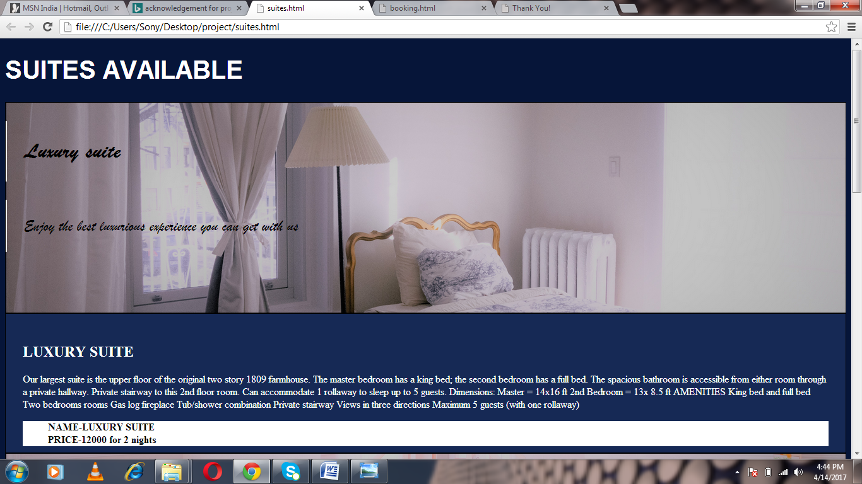

**Figure -2(a)**

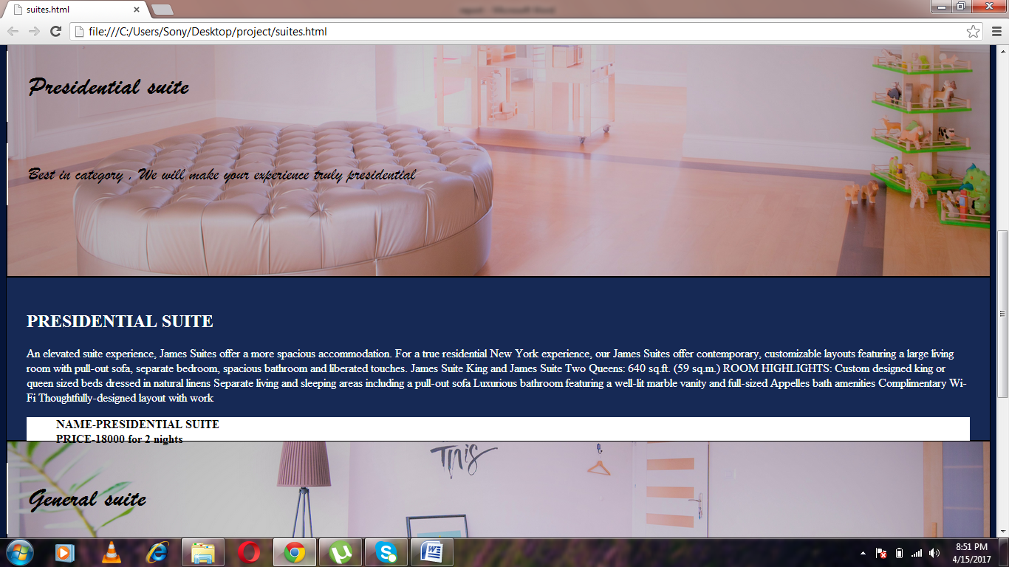

**Figure-2(b)**

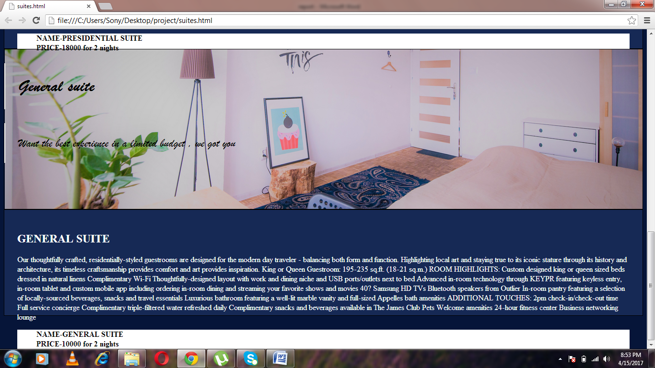

**Figure-2(c)**

**CODE 2-**

|  |  |
| --- | --- |
|  |  |
|  |  |
|  | <!DOCTYPE html> |
|  | <html> |
|  | <head> |
|  | <meta charset="utf-8"> |
|  | <meta http-equiv="X-UA-Compatible" content="IE=edge"> |
|  | <title></title> |
|  | <link rel="stylesheet" href=""> |
|  | <style type="text/css"> |
|  |  |
|  | body{ |
|  |  |
|  |  |
|  | background-color: #061539; |
|  | } |
|  |  |
|  |  |
|  | div#luxury_img , div#president_img , div#general_img{ |
|  | border:1px solid black; |
|  | height:50vh; |
|  | background-color: red; |
|  | } |
|  |  |
|  | div#luxury_img{ |
|  | background:url('luxury.jpg'); |
|  | background-repeat: no-repeat; |
|  | background-size: cover; |
|  | background-position: center; |
|  | } |
|  |  |
|  | div#president_img{ |
|  | background:url('president.jpg'); |
|  | background-repeat: no-repeat; |
|  | background-size: cover; |
|  | background-position: center; |
|  | } |
|  |  |
|  | div#general_img{ |
|  | background:url('general.jpg'); |
|  | background-repeat: no-repeat; |
|  | background-size: cover; |
|  | background-position: center; |
|  | } |
|  |  |
|  | div#luxury_abt , div#president_abt , div#general_abt{ |
|  | height:25vh; |
|  | border:1px solid black; |
|  | background-color:#162955 ; |
|  | font-size:16px; |
|  | padding:2%; |
|  | color:white; |
|  | } |
|  |  |
|  | header h1{ |
|  | color:white; |
|  | font-size:40px; |
|  | font-family:helvetica; |
|  | } |
|  |  |
|  | h2.up , p.middle_text{ |
|  | font-size: 35px; |
|  | padding: 2%; |
|  | border-left:2px solid white; |
|  | font-family: "Brush Script MT"; |
|  | } |
|  |  |
|  | p.middle_text{ |
|  | font-size:25px; |
|  | } |
|  |  |
|  | li{ |
|  | list-style-type: none; |
|  | font-weight: bold; |
|  | color:black; |
|  | } |
|  | ul{ |
|  | background-color: white; |
|  | } |
|  |  |
|  | </style> |
|  | </head> |
|  | <body> |
|  | <header><h1>SUITES AVAILABLE</h1></header> |
|  |  |
|  | <div id="luxury"> |
|  | <div id="luxury_img"> |
|  | <h2 class="up">Luxury suite</h2> |
|  | <p class="middle_text">Enjoy the best luxurious experience you can get with us</p> |
|  | </div> |
|  | <div id="luxury_abt"> |
|  | <h2>LUXURY SUITE</h2> |
|  | <p>Our largest suite is the upper floor of the original two story 1809 farmhouse. |
|  | The master bedroom has a king bed; the second bedroom has a full bed. |
|  | The spacious bathroom is accessible from either room through a private hallway. |
|  | Private stairway to this 2nd floor room. Can accommodate 1 rollaway to sleep up to 5 guests. |
|  | Dimensions: Master = 14x16 ft 2nd Bedroom = 13x 8.5 ft |
|  |  |
|  | AMENITIES |
|  |  |
|  | King bed and full bed |
|  | Two bedrooms rooms |
|  | Gas log fireplace |
|  | Tub/shower combination |
|  | Private stairway |
|  | Views in three directions |
|  | Maximum 5 guests (with one rollaway)</p> |
|  | <ul> |
|  | <li>NAME-LUXURY SUITE</li> |
|  | <li>PRICE-12000 for 2 nights</li> |
|  | </ul> |
|  | </div> |
|  | </div> |
|  |  |
|  | <div id="president"> |
|  | <div id="president_img"> |
|  | <h2 class="up">Presidential suite</h2> |
|  | <p class="middle_text">Best in category , We will make your experience truly presidential</p> |
|  | </div> |
|  | <div id="president_abt"> |
|  | <h2>PRESIDENTIAL SUITE</h2> |
|  | <p>An elevated suite experience, James Suites offer a more spacious accommodation. |
|  | For a true residential New York experience, our James Suites offer contemporary, customizable layouts featuring a large living room with pull-out sofa, |
|  | separate bedroom, spacious bathroom and liberated touches. |
|  | James Suite King and James Suite Two Queens: 640 sq.ft. (59 sq.m.) |
|  |  |
|  | ROOM HIGHLIGHTS: |
|  |  |
|  | Custom designed king or queen sized beds dressed in natural linens |
|  | Separate living and sleeping areas including a pull-out sofa |
|  | Luxurious bathroom featuring a well-lit marble vanity and full-sized Appelles bath amenities |
|  | Complimentary Wi-Fi |
|  | Thoughtfully-designed layout with work |
|  | </p> |
|  | <ul> |
|  | <li>NAME-PRESIDENTIAL SUITE</li> |
|  | <li>PRICE-18000 for 2 nights</li> |
|  | </ul> |
|  | </div> |
|  | </div> |
|  |  |
|  | <div id="general"> |
|  | <div id="general_img"> |
|  | <h2 class="up">General suite</h2> |
|  | <p class="middle_text">Want the best experience in a limited budget , we got you</p> |
|  | </div> |
|  | <div id="general_abt"> |
|  | <h2>GENERAL SUITE</h2> |
|  | <p>Our thoughtfully crafted, residentially-styled guestrooms are designed for the modern day traveler - |
|  | balancing both form and function. Highlighting local art and staying true to its iconic stature through its history and architecture, |
|  | its timeless craftsmanship provides comfort and art provides inspiration. |
|  | King or Queen Guestroom: 195-235 sq.ft. (18-21 sq.m.) |
|  |  |
|  | ROOM HIGHLIGHTS: |
|  |  |
|  | Custom designed king or queen sized beds dressed in natural linens |
|  | Complimentary Wi-Fi |
|  | Thoughtfully-designed layout with work and dining niche and USB ports/outlets next to bed |
|  | Advanced in-room technology through KEYPR featuring keyless entry, in-room tablet and custom mobile app including ordering in-room dining |
|  | and streaming your favorite shows and movies |
|  | 40? Samsung HD TVs |
|  | Bluetooth speakers from Outlier |
|  | In-room pantry featuring a selection of locally-sourced beverages, snacks and travel essentials |
|  | Luxurious bathroom featuring a well-lit marble vanity and full-sized Appelles bath amenities |
|  |  |
|  | ADDITIONAL TOUCHES: |
|  |  |
|  | 2pm check-in/check-out time |
|  | Full service concierge |
|  | Complimentary triple-filtered water refreshed daily |
|  | Complimentary snacks and beverages available in The James Club |
|  | Pets Welcome amenities |
|  | 24-hour fitness center |
|  | Business networking lounge |
|  | </p> |
|  | <ul> |
|  | <li>NAME-GENERAL SUITE</li> |
|  | <li>PRICE-10000 for 2 nights</li> |
|  | </ul> |
|  | </div> |
|  | </div> |
|  |  |
|  | </body> |
|  | </html> |

1. **BOOKING-**

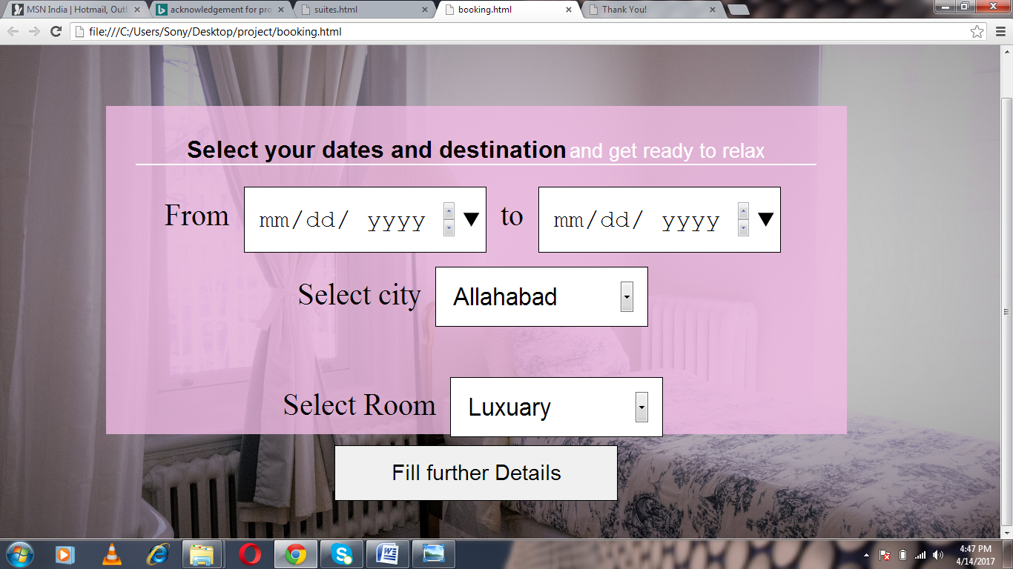

**Figure-3**

**CODE 3-**

|  |  |
| --- | --- |
|  |  |
|  | <!DOCTYPE html> |
|  | <html> |
|  | <head> |
|  | <meta charset="utf-8"> |
|  | <meta http-equiv="X-UA-Compatible" content="IE=edge"> |
|  | <title></title> |
|  | <link rel="stylesheet" href=""> |
|  | <style type="text/css"> |
|  |  |
|  | body{ |
|  | background:url('luxury.jpg'); |
|  | background-size:cover; |
|  | background-repeat: no-repeat; |
|  |  |
|  | padding:10%; |
|  | text-align: center; |
|  | } |
|  |  |
|  | div#jumbotron{ |
|  | padding:2%; |
|  | width:70vw; |
|  | height:60vh; |
|  | background:rgba(242, 188, 229,0.8) |
|  |  |
|  |  |
|  | } |
|  |  |
|  | form{ |
|  | font-size:3vw; |
|  |  |
|  | } |
|  |  |
|  | input , select{ |
|  | width: 30%; |
|  | padding:2%; |
|  | border:1px solid black; |
|  | font-size: 80%; |
|  | margin:1%; |
|  | } |
|  | header{ |
|  | font-family: helvetica; |
|  | border-bottom: 2px solid white; |
|  | margin:2%; |
|  | } |
|  | h1{ |
|  | display: inline; |
|  | } |
|  | small{ |
|  | color:white; |
|  | font-size: 2vw; |
|  | } |
|  | button{ |
|  | width:40%; |
|  | padding:2%; |
|  | border:1px solid black; |
|  | font-size: 70%; |
|  | } |
|  | button:hover{ |
|  | background-color:#d317c3; |
|  | } |
|  | a{ |
|  | color:black; |
|  | text-decoration: none; |
|  | } |
|  |  |
|  | </style> |
|  |  |
|  |  |
|  | </head> |
|  | <body> |
|  | <div id="jumbotron"> |
|  | <header> |
|  | <h1>Select your dates and destination</h1> <small>and get ready to relax</small></header> |
|  | <form name="bookingForm"> |
|  |  |
|  | <label for="forDate">From</label> |
|  | <input type="date" name="fromDate" id="fromDate"> |
|  | <label for="toDate">to</label> |
|  | <input type="date" name="toDate" id="toDate"></br> |
|  | <label>Select city</label> |
|  | <select> |
|  | <option value="Allahabad">Allahabad</option> |
|  | <option value="Bhubneshwar">Bhubneshwar</option> |
|  | <option value="chandigarh">Chandigarh</option> |
|  | <option value="mumbai">Mumbai</option> |
|  | <option value="Goa">Goa</option> |
|  | <option value="gujarat">Gujarat</option> |
|  | <option value="pune">Pune</option> |
|  | <option value="himachal">Himachal Pradesh</option> |
|  | <option value="uttrakhand">Uttrakhand</option> |
|  | <option value="Jammu">Jammu and Kashmir</option> |
|  | <option value="chennai">Chennai</option> |
|  | <option value="Banglore">Banglore</option> |
|  | <option value="delhi">Delhi</option> |
|  | </select></br> |
|  | <br> |
|  | <label>Select Room</label> |
|  | <select> |
|  | <option value="LUXURY">Luxuary</option> |
|  | <option value="PRESIDENTIAL">Presidential</option> |
|  | <option value="GENERAL">General</option> |
|  | </select></br> |
|  |  |
|  | <button type="button" id="further"><a href="form.html">Fill further Details</a></button> |
|  | </form> |
|  | </div> |
|  |  |
|  |  |
|  | </body> |
|  | </html> |

1. **SIGN UP-**

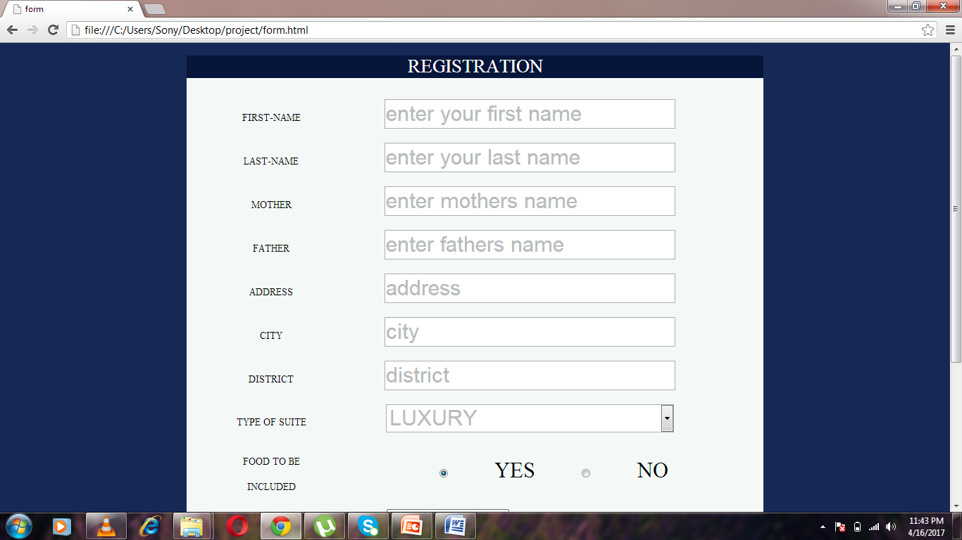

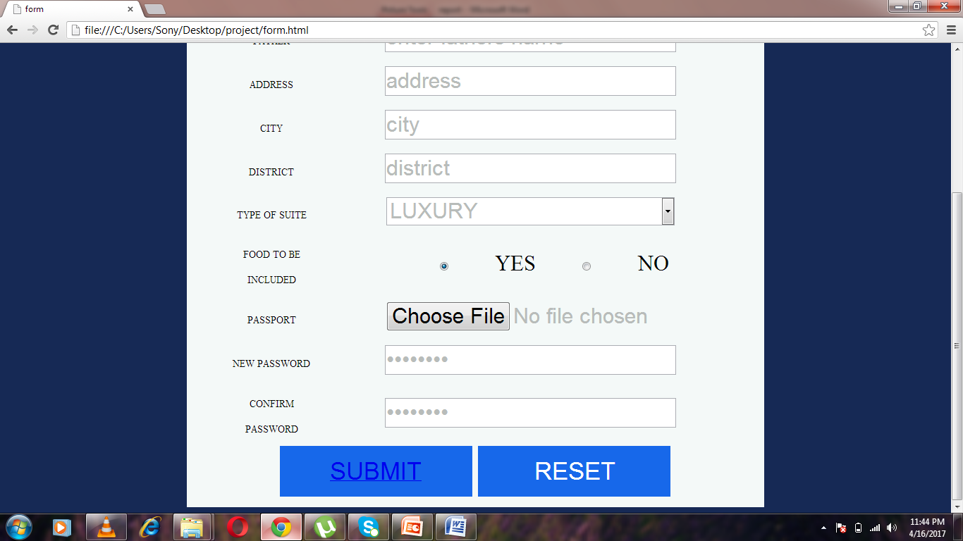

**Figure-4**

**CODE 4-**

|  |  |
| --- | --- |
|  |  |
|  |  |
|  |  |
|  |  |
|  | <!DOCTYPE html> |
|  | <html> |
|  | <head> |
|  | <meta charset="utf-8"> |
|  | <meta http-equiv="X-UA-Compatible" content="IE=edge"> |
|  | <title>form</title> |
|  | <link rel="stylesheet" href="form1.css"> |
|  | </head> |
|  | <body> |
|  | <form action="form_submit" method="get" accept-charset="utf-8"> |
|  | <h1>REGISTRATION</h1> |
|  | <table> |
|  |  |
|  | <tr> |
|  | <td><label for="firstname">FIRST-NAME</label></td><td><input type="text" name="firstname" value="enter your first name"></td></tr><tr> |
|  | <td><label for="lastname">LAST-NAME</label></td><td><input type="text" name="lastname" value="enter your last name"><br></td></tr><tr> |
|  | <td><label for="mother">MOTHER</label></td><td><input type="text" name="mother" value="enter mothers name"><br></td></tr><tr> |
|  | <td><label for="father">FATHER</label></td><td><input type="text" name="father" value="enter fathers name"><br></td></tr><tr> |
|  | <td><label for="address">ADDRESS</label></td><td><input type="text" name="address" value="address"></td></tr><tr> |
|  | <td><label for="city">CITY</label></td><td><input type="text" name="city" value="city"><br></td></tr><tr> |
|  | <td><label for="district">DISTRICT</label></td><td><input type="text" name="district" value="district"><br></td></tr><tr> |
|  | <td><label for="typeofsuite">TYPE OF SUITE </label></td><td><select name="courses"> |
|  | <option value="luxury">LUXURY</option> |
|  | <option value="presidential">PRESIDENTIAL</option> |
|  | <option value="dreamy">DREAMY</option> |
|  | <option value="general">GENERAL</option> |
|  | <option value="budget">BUDGET</option> |
|  | </select></td></tr><tr> |
|  | <td><label for="food">FOOD TO BE INCLUDED</label></td><td><input type="Radio" name="hyes" value="yes" id="chk" CHECKED>YES<input type="Radio" name="hno" value="no" id="chk">NO</td></tr><tr> |
|  | <td><label for="pic">PASSPORT</label></td><td><input type="file" name="passport" value="choose your pic" ></td></tr><tr> |
|  |  |
|  | <td><label for="password">NEW PASSWORD</label></td><td><input type="password" name="password" value="password"></td></tr><tr> |
|  | <td><label for="password">CONFIRM PASSWORD</label></td><td><input type="password" name="password" value="password"></td></tr> |
|  |  |
|  | </table> |
|  | <button type="submit"><a href="th.html">SUBMIT</a></button> <button type="reset">RESET</button> |
|  | </form> |
|  | <script> |
|  |  |
|  | inp=document.getElementsByTagName('input'); |
|  | var i=0; |
|  | for(i;i<9;i=i+1){ |
|  | inp[i].addEventListener('click',function(){ |
|  | this.value=" "; |
|  | }); |
|  | inp[i].addEventListener('blur',function(){ |
|  | if(this.value==" "){ |
|  | alert('please fill '+this.name+' empty field'); |
|  | } |
|  | }); |
|  |  |
|  | } |
|  |  |
|  | </script> |
|  | </body> |
|  | </html> |
|  |  |

1. **FEEDBACK-**

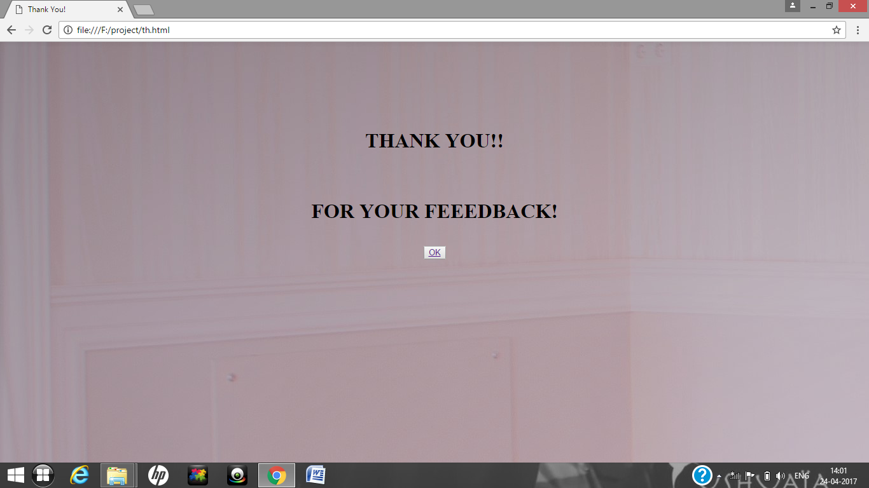

**Figure-5**

**CODE 5-**

|  |  |
| --- | --- |
|  |  |
|  | <!DOCTYPE html> |
|  | <html> |
|  | <head> |
|  |  |
|  | <title>Thank You!</title> |
|  |  |
|  | <style> |
|  | body{ |
|  | background-image:url("president.jpg"); |
|  | } |
|  | </style> |
|  | </head> |
|  | <body><br><br><br><br><br><br> |
|  | <h1><center> |
|  | THANK YOU!!<br><br><br> |
|  | FOR YOUR FEEEDBACK!</center></h1> |
|  | <form> |
|  | <center><h1><button type="ok"><a href="mainview1.html">OK</a></button></center></h1></form> |
|  |  |
|  | </body> |
|  |  |
|  | </html> |
|  |  |
|  |  |

1. **CONTACT-**

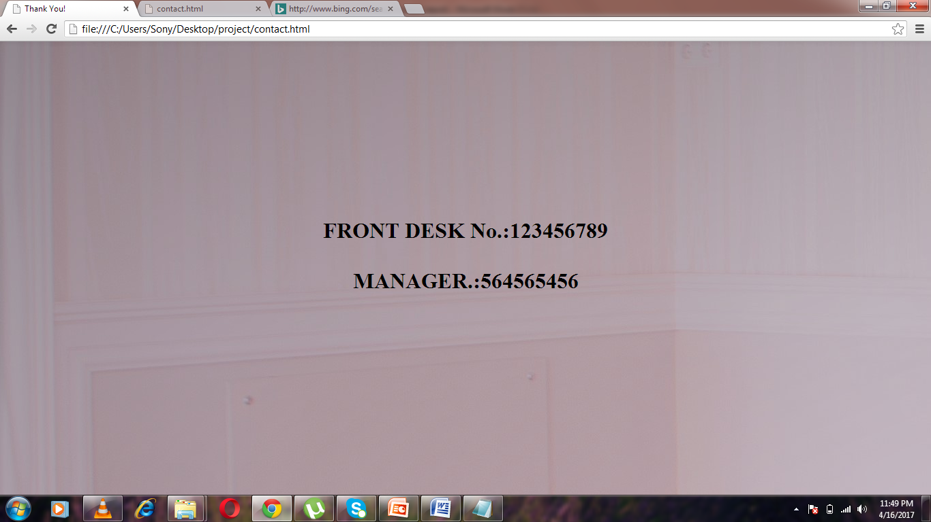

**Figure-6**

**CODE 6-**

|  |  |
| --- | --- |
|  |  |
|  | <!DOCTYPE html> |
|  | <html> |
|  | <head> |
|  |  |
|  | <title>Thank You!</title> |
|  |  |
|  | <style> |
|  | body{ |
|  | background-image:url("president.jpg"); |
|  | } |
|  | </style> |
|  | </head> |
|  | <body><br><br><br><br><br><br> |
|  | <h1><center> |
|  | Front Desk.:123456789<br><br><br> |
|  | Manager.:564565456</center></h1></body> |
|  | </html> |
|  |  |
|  |  |

**CODING-**

For the codings of each page we can refer to the codes that are mentioned before with the screen layouts.

* Home page- refer code 1
* Suites- refer code 2
* Contacts- refer code 3
* Booking – refer code 4
* Sign up – refer code 5

**REFRENCES-**

During the project different sites and different books were refred.

These are mentioned as below

-Introduction to JavaScript

-Internet explorer

-Youtube (for the basic tutorials)

**LIMITATIONS-**

-Due to the time shortage we are not able to access the database which would help us to know about the particular details filled by our guest.

We will try to overcome this limitation in the future for the proper access of our site.

**INDEX**

|  |  |  |
| --- | --- | --- |
| **S.NO** | **TOPIC** | **PAGE NUMBER** |
| 1 | Acknowledgement | 1 |
| 2 | INTRODUCTION | 2-3 |
| 3 | SCREEN LAYOUTS-  HOME PAGE | 4 |
| 4 | CODE 1 | 5-6-7 |
| 5 | SUITES | 8-9 |
| 6 | CODE 2 | 10-11-12-13 |
| 7 | BOOKING | 14 |
| 8 | CODE 3 | 15-16-17 |
| 9 | SIGN-UP | 18 |
| 10 | CODE-4 | 19-20 |
| 11 | FEEDBACK | 21 |
| 12 | CODE 5 | 22 |
| 13 | CONTACT | 23 |
| 14 | CODE 6 | 24 |
| 15 | CODING-REFRENCES-LIMITATION | 25 |

**MCM DAV COLLEGE FOR WOMEN**

**SUBMITTED TO: SUBMITTED BY:**

**Dr. Indu Arora Urvashi Singh**

**6255(BCA-III)**